**Example 6.19 Sudden release of heat in to an infinite rod**

A rod (diameter = 1cm, length = 0.4m) initially at 30C is maintained at 30C at its two ends. Suddenly at the middle of the rod, over a span of Δx, 1000J of heat energy is released into the rod at time t = 0 sec. The rod loses heat in to the ambient through convection where the heat transfer coefficient is h = 50w/m2-C and the ambient temperature is 30C. If the thermal properties of the rod are: k = 50 w/m-C, rho=2700 kg/m3, c = 470 J/kg-C then compute the temperature in the rod as a function of time.

In order to simulate an infinite rod we may not really take a very long length. For this problem a length of 0.4m is enough if we restrict our attention to only about 100s or less. If the amount of heat released to the rod at its central plane is Qtot ,  then we get;

, *T0* is the initial temperature of the rod (6.80)

If *Δx* is too small then the temperature at the point of heat release (*Tloc*) will be very high. However, for a practical solution we may keep *Δx* to be 1cm or 5mm or take very small cells and see its effect on the temperature profile. The governing equation of heat conduction in the rod will be Eqn.(7.42)

$\frac{c}{k}\frac{∂T}{∂t}=\frac{∂^{2}T}{∂x^{2}}-\frac{hP}{kA}\left( T-T_{∞}\right)$ (6.80a)

At $t=0, T=T_{0}$ everywhere except at the point of heat release where *T = Tloc* . So, we have to make a procedure where we can decide the initial temperature distribution in the rod.

At x = 0 and x = L , *T = T0* as has been prescribed by our problem.

So now we can proceed to write all the equations in our EES equation window. We would prefer to solve this by the integral command.

procedure temp(x_loc, x , t0, t_loc: t)

if (x_loc=x ) then { initial temperature distribution in the rod}

t=t_loc

else

t=t0

endif

end

h=50; p=pi*d; d=.01; a=pi*d^2/4; t_inf=30; t0=30 ; { initial temp of rod}

k=50; l=.4[m]; rho=2700;cp=470

x_loc=.2; dx=l/ni; ni=40; time=10; st=.1; alpha=k/(rho*cp); fac=h*p/(rho*cp*a)

q_total=1e3[j]; q_total= rho*cp*a*dx*(t_loc-t0) { total heat supplied to the rod at x=x_loc at t =0}

duplicate i=1,ni+1

x[i]=(i-1)*dx

call temp(x_loc, x[i], t0, t_loc: t_ini[i])

end

duplicate i=2,ni

(t[i+1]-2*t[i]+t[i-1])/dx^2-h*p/(k*a)*(t[i]-t_inf) =rho*cp/k*t`[i]

t[i]=t_ini[i]+integral(t`[i], ti, 0 , time, st)

t_th[i]=t0+q_total*exp(-fac*time-(x[i]-x_loc)^2/(4*alpha*time))/(2*a*rho*cp*sqrt(pi*alpha*time))

end

t[1]=t0 ; t[ni+1]=t0 ;

$integraltable ti: .1, t[1..41]

**Panel 6.19** Equation window for solution of Example problem 6.19

On the top of the equation window the procedure ‘temp’ decides the initial temperature distribution in the rod and the call statement in the duplicate loop calls the procedure and stores the initial temperature (in the array t_ini) as a function of x. Then the next duplicate loop solves equation (6.80a) by the integral command. Mark that, the second derivative of T with respect to x is written in finite difference form along with the heat loss term (right side second term of Eqn. (6.80a)). The left hand side transient term of Eqn.(6.80a) is written as t`[i] which would be integrated with respect to time. The analytical solution of Eqn. (6.80a) is [5]:

$T_{ana}=T_{0}+Q_{tot}\frac{e^{- \frac{hPt}{ cA} - \frac{{\left(x-x_{l}\right)}^{2}}{4 t}}}{2A c \sqrt{π t}}$ (6.81)

In the analytical solution *P* = perimeter, *A* = cross sectional area of the rod and *xl*is the location of heat release. We can now compare our numerical solution with the analytical solution, which is written on the 4th line from bottom in the equation window.

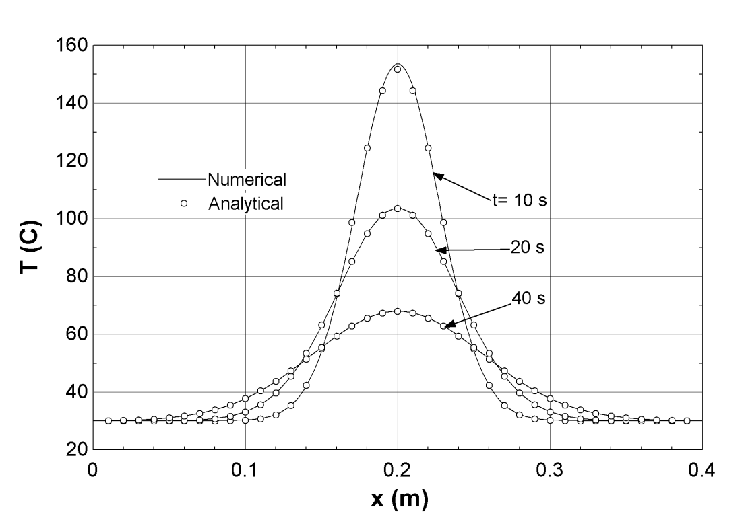

Fig.6.29 Temperature distribution in the rod for a sudden heat release of 1000J at the center of it and a comparison with analytical solution

Fig.6.19 shows a good comparison between the numerical and the analytical solution. The effect of grid size and the time step of integration on the numerical solution can be studied by simply varying the value of ‘ni’ and ’st’ in the equation window.

**Example 6.20 Moving heat source on a rod**

A rod (diameter =1cm, length =1m) initially at 30C, is maintained at 30C at both its ends while it is subjected to an annular heat source which starts at x = 0.2m on the rod and travels to the right at a speed of 0.02m/s. The heat source is able to deliver 1000 J in every 5s over the rod surface and the heat loss to the ambient can be assumed to be zero from the source. However, the rod surface loses heat to the ambient through convection (h = 50w/m2-k and T∞ = 30C). The thermal properties of the rod are; k = 50w/m-k, ρ = 2700 kg/m3, c = 470 J/kg-C. Compute the temperature profile in the rod at a time of 5, 10, 15, 20 and 30s after the source has started to move on the rod.

The governing equation for this case will be somewhat similar to that of Eqn.(6.80a), where an additional term because of heat addition due to the moving source is added.

$\frac{c}{k}\frac{∂T}{∂t}=\frac{∂^{2}T}{∂x^{2}}-\frac{hP}{kA}\left( T-T_{∞}\right)+\frac{\dot{Q} P}{kA}$ (6.82)

$Q=\dot{Q }P ∆x time$ (6.82a)

The amount of heat added in every 5 sec is 1000J, so the value of Q = 1000. If we would like to solve the temperature profile at a time of 5sec then the value of time = 5s. *P* is the perimeter of the rod and $∆x$ (L / number of cells) is the cell size on the rod which would be used for the simulation. If we would be interested to get the temperature profile at a time of 10sec or 20sec then the value of Q would be 2000 J or 4000 J because in 10 or 20 sec the amount of heat given by the source would be just doubled or quadrupled to that given during 5sec. So the value of $\dot{Q }$ would vary depending on the cell size we are going to use, whereas the heat given by the source is a constant during a definite time interval. This means $\dot{Q }$ remains a constant as long as $∆x$ remains a constant.

Since the source travels to the right at a certain speed, so the addition of $\dot{Q }$ at the grid point has to be done properly. When, the source moves from one cell to the other the value of $\dot{Q }$ also moves from one cell to the other. When the source has passed a particular cell the value of $\dot{Q }$ in that cell would be set to zero and the cell which is directly under the source there the value of $\dot{Q }$ would be set to the right value. This is done in a procedure “qcal” which is put at the beginning of the equations window.

If the velocity of the source is small and the cell size, $∆x$ is larger than the value of v $∆t$ then the source would be present at that cell for a time such that, $v ∆t= ∆x$. This means our source is moving in a stepwise manner (not continuously) since we are using a fixed grid for the simulation. If we increase the number of cells, or in other words decrease the size of the cell then the stepwise movement of the source would look continuous.

procedure qcal(x, dx, x_loc, v, t ,q1_dot : q_dot); {t=time here}

xp=(x_loc+v*t-x)*(x_loc+v*t-(x+dx));

if (xp <= 0) then q_dot=q1_dot

if (xp > 0) then q_dot=0

end

h=50; p=pi*d; d=.01; a=pi*d^2/4; t_inf=30; k=50; l=1[m]; v=.02[m/s]; rho=2700;cp=470

x_loc=.2; dx=l/ni; ni=50; time=20; st=.025

q_total=4e3[J]; q_total=q1_dot*p*dx*time { total heat supplied should be fixed for a time}

duplicate i=1,ni+1

x[i]=(i-1)*dx

end

duplicate i=2,ni

call qcal(x[i], dx, x_loc, v, ti,q1_dot :q_dot[i])

(t[i+1]-2*t[i]+t[i-1])/dx^2-h*p/(k*a)*(t[i]-t_inf)+q_dot[i]*p/(k*a)=rho*cp/k*t`[i]

t[i]=30[c]+integral(t`[i],ti,0,time,st)

q[i]=integral(q_dot[i]*p*dx,ti,0,time,st)

end

q_comp=sum(q[i],i=2,ni) { q_comp and q_total should be almost same}

t[1]=30[c] ; t[ni+1]=30[c]; q_dot[1]=0

$integraltable ti:.1,t[1..51],q_dot[1..50]

**Panel 6.20** Equation window for the solution of Example problem 6.20

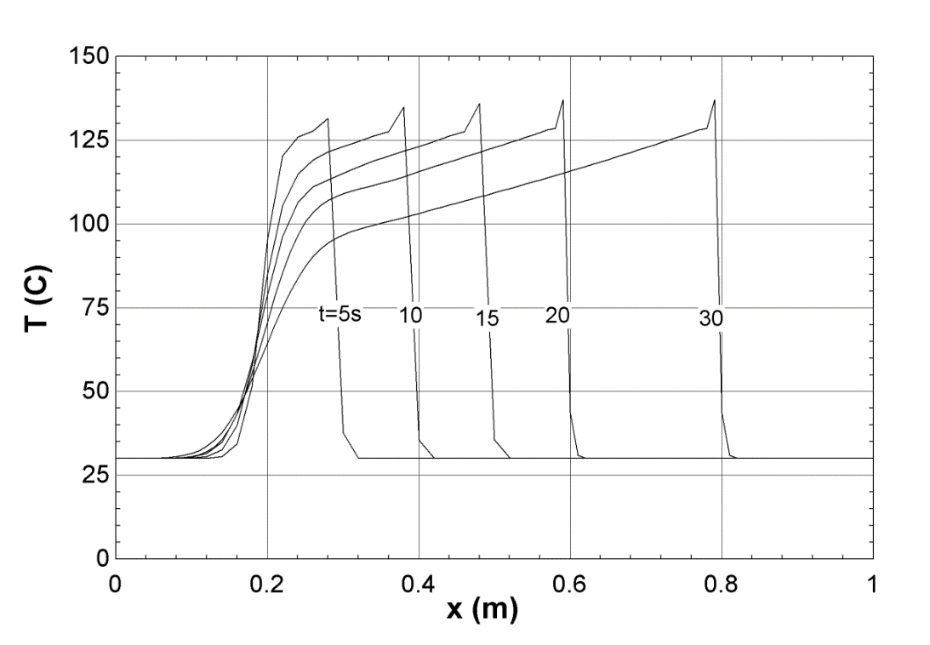Solution of Eqn.(6.82) is written in the equation window in Panel 6.20. At every cell location we compute the amount of heat that goes in to the cell and add all the heat over the cells where the source has travelled. The computed value of q_comp should almost match with that of q_total. If this does not happen then an error has been done somewhere and the program qcal has to be checked and q has to be plotted as a function of x to see if any anomaly is present in the program.

Fig. 6.30 Temperature distribution in the rod as a function of time subjected to a moving heat source

Fig.6.30 shows the temperature profile in the rod as a function of x at different times. The source starts from x = 0.2m and in 30sec it has travelled up to x = 0.8m. While travelling it would heat the sections on the way and then immediately the section would lose heat to the surroundings by convection causing the section temperature to fall with time.